Bilious vomiting discussion

Common causes of a bowel obstruction in this age group include pyloric stenosis, volvulus, and intussusception. Other possibilities include constricting bands overlying bowel, intraluminal webs, intestinal stenosis, annular pancreas, etc.

An ultrasound would be the best study to evaluate a possible pyloric stenosis. An UGI series can also be performed to diagnose pyloric stenosis, but ultrasound involves no radiation, it does not require oral contrast, and it is more accurate than an UGI series in diagnosing pyloric stenosis. Her clinical findings are not consistent with pyloric stenosis. Her vomiting is not projectile in nature and it is not associated with feeding. Her vomitus is definitely bilious suggesting an obstruction below the pylorus.

An intussusception would be most accurately visualized on a barium enema. Ultrasound is capable of making the diagnosis most of the time. However, if the ultrasound is negative, how certain can you be that intussusception has been ruled out. In other words, what is its false negative rate. Since ultrasound is highly operator and interpreter dependent, these factors must be discussed with the ultrasonographer on call in order to decide whether ultrasound is a plausible option to rule out intussusception. In cases which have a high likelihood of intussusception, a barium enema would be better since the barium enema has the additional advantage of potentially reducing the intussusception most of the time. This is not possible with ultrasound. Air contrast enema has also been used in the diagnosis and reduction of intussusception. This option should be discussed with your radiologist.

In our patient's case, a malrotation with volvulus is the most likely diagnosis. The abdominal radiographs suggest a high obstruction just distal to the gastric outlet since there is a paucity of gas distal to the stomach. Her history of colic and the previous vomiting episode raises the possibility of intermittent volvulus which is often a presentation for malrotation. Although bilious emesis can occur with any type of bowel obstruction (including lower obstructions such as intussusception) and even an ileus, it is also suggestive of a high obstruction. Radiographically, an ileus should have a good distribution of gas throughout the abdomen. Our patient's abdominal radiographs are highly suggestive of an obstruction and not an ileus because of the poor gas distribution.

An ultrasound of the abdomen is performed. It is negative for pyloric stenosis and there are no indings to suggest an intussusception. An upper GI series is ordered. It initially shows no barium passing out of the stomach. However a subsequent view following the administration of thin barium shows the following: 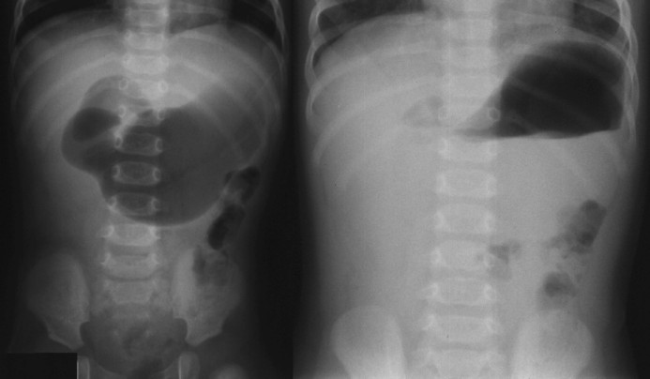

View upper GI series film.

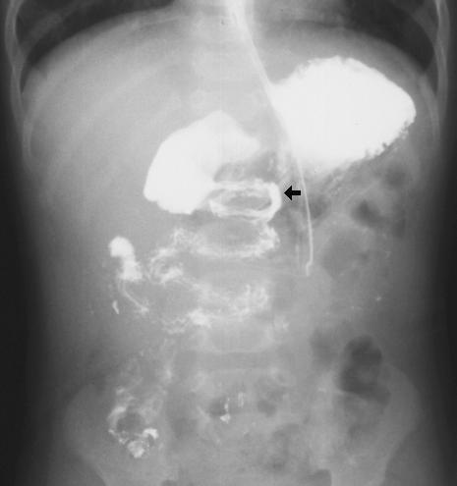

This pattern of contrast flow, sometimes referred to as a corkscrew (black arrow), shows thin barium flowing in a spiral fashion through a restricted bowel lumen. This indicates the presence of a midgut volvulus. Compare this to the diagram of a midgut volvulus.

View diagram of a midgut volvulus.

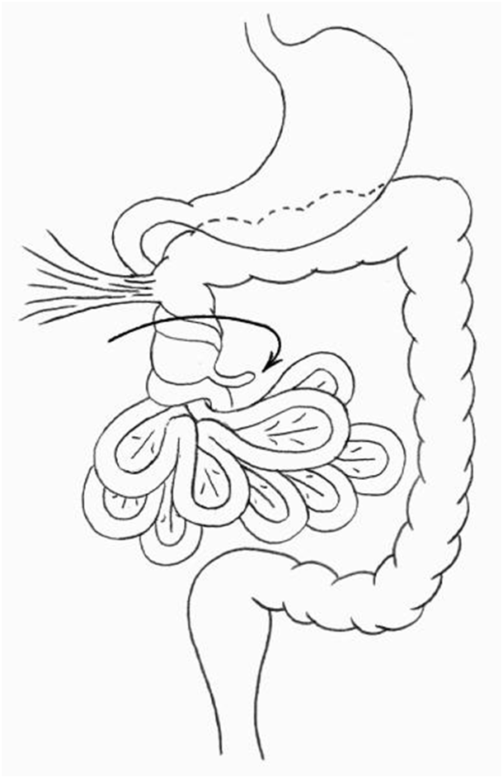

You can see the tight strangulation of the upper small bowel volvulus forming a spiraling corkscrew pattern as seen in the UGI series.

It may be difficult to radiographically demonstrate a volvulus in all instances. Plain abdominal radiographs may range from gasless to normal. A barium enema may be able to demonstrate the cecum in the wrong place suggesting a malrotation and a likely associated midgut volvulus. An upper GI series may fail to demonstrate the volvulus itself, however, it will show a sudden obstruction in the bowel lumen where the barium fails to pass. Using thin barium or soluble contrast may help to demonstrate the volvulus, however, it may be necessary to take the patient to surgery based on indirect radiographic findings alone.

An UGI series may also demonstrate malrotation (with or without a volvulus) by demonstrating malpositioning of the duodenal-jejunal junction. Examine the UGI film again.

View UGI film.

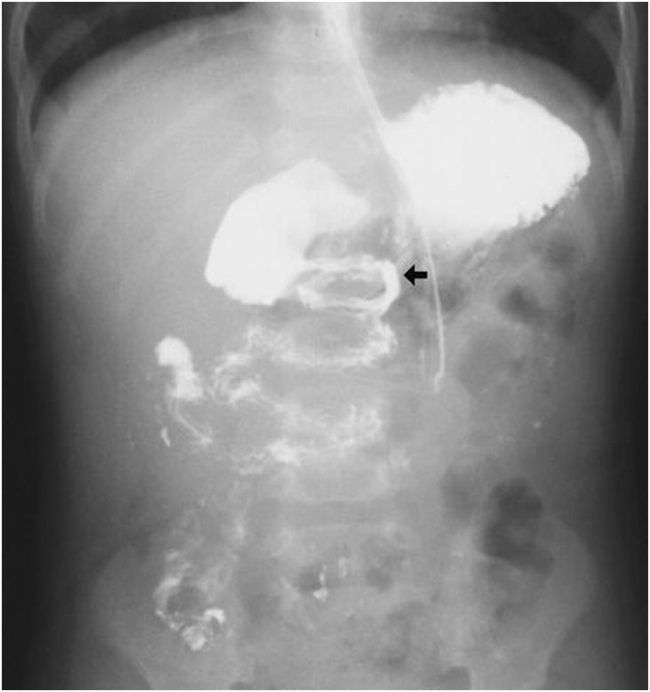

The black arrow points to the duodenal-jejunal junction. The normal duodenum starts at the gastric

outlet (duodenal bulb) and extends toward the right. It then loops around downward and to the left, and then superiorly and to the left so that the duodenoal-jejunal junction is normally to the left of the spine at the same level as the duodenal bulb. In this case, the duodenal-jejunal junction is clearly inferior to the duodenal bulb. This indicates the presence of a malrotation.